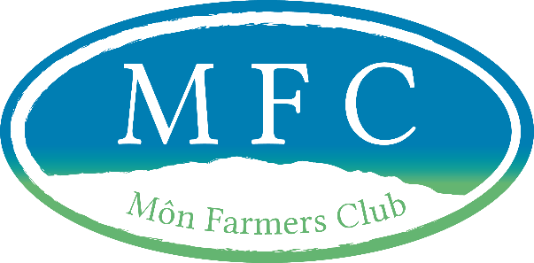
Membership Form 2021-2022

If completing by hand, please complete in blue/black ink in BLOCK CAPITALS.
Full Name
Address
Postcode
E-mail Address
Home Phone
Mobile Phone

Signature _ _ _ _ _ _ _ _ _ _ _ _ _ Date _ _ _ _ _ _ _ _ _

The completed forms must be returned to Ceinwen Parry along with the payment of £20 membership for the year.  For further information please contact Ceinwen on  07444 801705 neu e-bost: Cffm2021@btinternet.com | C Parry  11 Bryn Ffynnon  Star  Ynys Môn  LL60 6BA

Your details will not be shared with any 3rd parties purposes.

